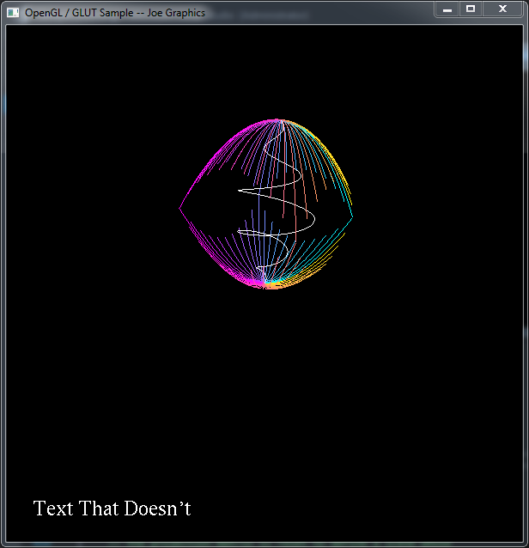

Video Link: https://media.oregonstate.edu/media/t/0_r6m3qvsk

Video transcript:

For project 1 I just wanted to play with some of the equations I learned about during all my years of math classes. It started with a circle that turned into the spiral shape in the center of the drawing. To get the spiral I drew a circle point by point with varying Z and radius values. The spiral is drawn with 1000 points. They very colorful curves encasing the spiral are parabolas rotated around the Z-axis. I created the rotation by relating X and Y with a ratio. This is also the reason some parabolas are shorter than others. Each parabola is drawn twice; the first time it is drawn normally then the second time through each point is flipped over the XY plane and moved upwards with a Z-offset. Each parabola has 1000 points.